Adolescent alcohol use

What happens when I drink alcohol?
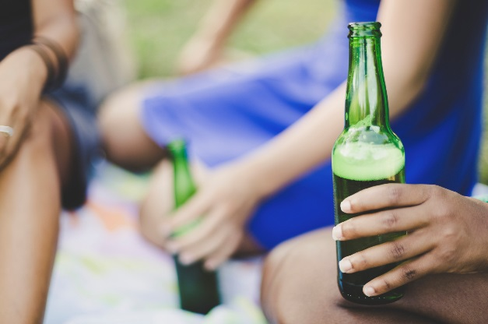
Alcohol is a drug that that enters the stomach and then the blood. Most people feel the effects of alcohol after 5 or 10 minutes of drinking. Alcohol affects the way the body works by changing the mind, the body, and the emotions.
Alcohol affects our breathing and heart rate, as well as how we think, feel, perceive things and behave. Because alcohol can make us more carefree or excitable, many people think alcohol is actually a stimulant drug. But it isn’t.
Alcohol is a depressant. The more you drink the more likely you are to feel sleepy or drowsy or more emotional.

What are the risks of teen alcohol use?

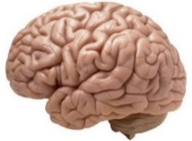
Teens who binge drink at least once a month damage their brains. As a result, it can become harder to pay attention and learn new information. Drinking as a teenager makes it more likely that a person becomes addicted to alcohol later in life.
22% of teenage drivers who died in car crashes were drinking. Car crashes are the leading cause of teen deaths. Teens are also more likely to hurt themselves when drinking – injuries are the third leading cause of death among teen agers.
The more a teen drinks alcohol, the lower his or her grades are likely to go down. High school students who use alcohol are five times more likely to drop out than those who don't drink. Students who drink heavily are more likely to oversleep, skip class and forget homework.
Drinking makes it more likely to be sexually assaulted, get a sexually transmitted disease, or become pregnant. Teenagers who spend a lot of time going to parties to drink may stop seeing friends who don’t. A teen who drinks may stop showing up for work and lose their job.

Because of these risks, it is recommended that teens not drink any alcohol. When teens do drink, however, they might not know how much they are drinking.

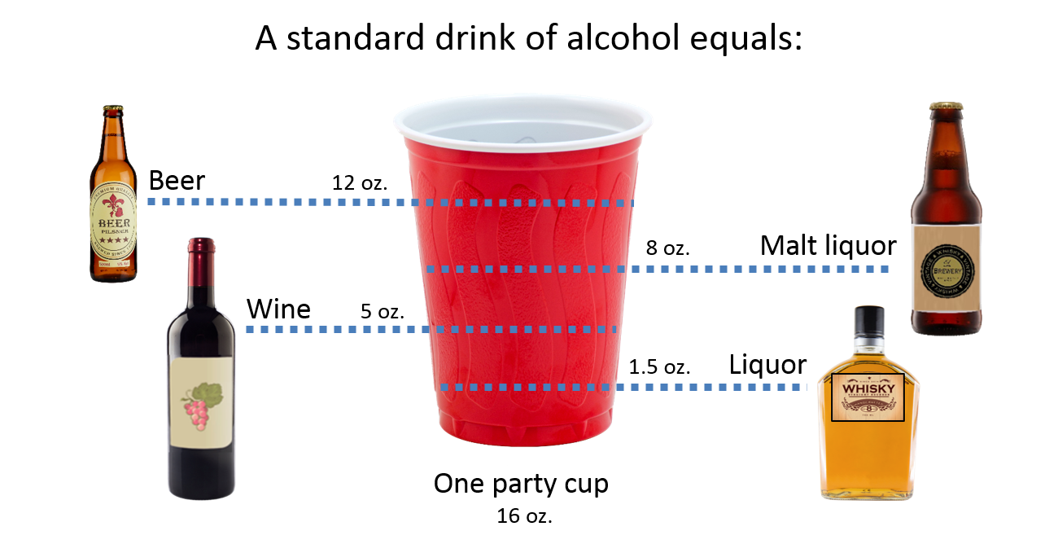

It takes about an hour for the effects of every standard drink to wear off. Drinking coffee, getting fresh air, throwing up or taking cold showers do not help your body to process alcohol faster.

Myths and facts about teen drinking
Myth: Drinking is a good way to relax and have fun at parties.
FACT: Drinking can make you look silly, say things you shouldn’t say, and do things you wouldn’t normally do (like get into fights or have sex).
Myth: Drinking alcohol makes teens cool.
FACT: There’s nothing cool about stumbling around, passing out, or puking on yourself. Drinking alcohol also can cause bad breath and weight gain.
Myth: All of the other kids drink alcohol.
FACT: Most young people don’t drink alcohol. Studies show that more than 70 percent of youth aged 12 to 20 haven’t had a drink in the past month.
Myth: Adults drink, so teens should be able to drink too.
FACT: A young person’s brain and body are still growing. Drinking alcohol can cause learning problems or lead to adult alcoholism. People who begin drinking before age 15 are five times more likely to abuse alcohol or become addicted than those who begin drinking after age 21.

Myth: Beer and wine are safer than liquor.
FACT: Alcohol is alcohol - it can cause you problems no matter how you drink it. One 12-ounce bottle of beer or a 5-ounce glass of wine has as much alcohol as a shot of liquor.
Myth: I can drink alcohol and not have any problems.
FACT: If you’re under 21, drinking alcohol is a big problem: It’s illegal. If caught, you may have to pay a fine, perform community service, or take alcohol awareness classes. Teens who drink also are at higher risk for being a crime victim.

Tips to avoid impaired driving or riding
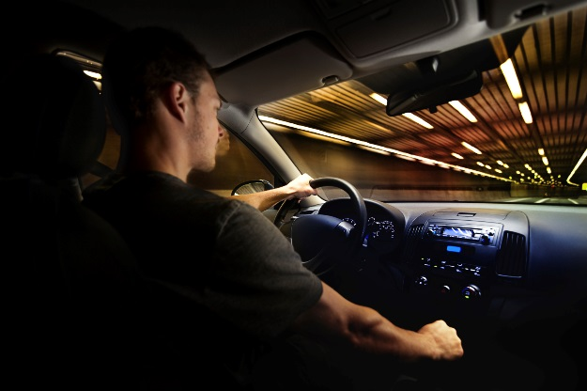
- Sign a contract with your parents agreeing that you will never drive after drinking or ride with someone who has. Your parents agree to pick you up, no questions asked.
- Create a secret text code like 2-2-2, or a phrase such to alert your parents or trusted adult that you need a safe ride and don’t want your friends to know.
- Use other ways to travel, such as the bus or taxi service. If you plan to drink, choose a driver who agrees not to drink. Ask a sober friend to drive you home.

Addiction to alcohol
Some teens who drink alcohol may not be able to stop drinking, even if they wanted to. When this happens, it may mean they are becoming addicted to alcohol. This is called an alcohol use disorder.
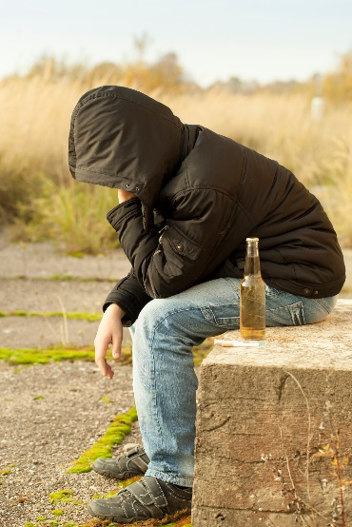
The signs of alcohol use disorder can sneak up on you. Be aware of these signs:
- Using alcohol to deal with feeling angry or sad
- Drinking on weekday evenings or during the day
- Drinking more and more over time
- Not showing up for school, sports, or clubs
- Using alcohol to go to sleep
- Friends saying they are worried about your drinking
- “Blacking out” or forgetting what you did while drinking
- Drinking more than you wanted to

This document is available at www.sbirtoregon.org. Information compiled from sources including the Substance Abuse and Mental Health Services Administration. All images licensed for use.

