Adolescent marijuana use

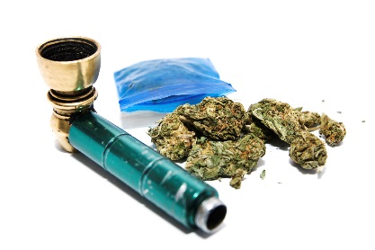
What happens when you use marijuana:
When marijuana is smoked or vaped, a person’s heart rate speeds up, breathing pathways get bigger, and blood veins in the eyes expand, making the eyes look bloodshot (red).
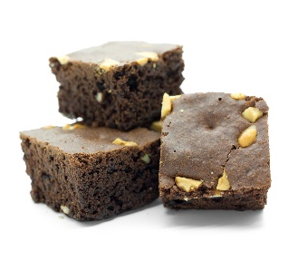
Chemicals in marijuana smoke or vapor go from the lungs into the blood and to the rest of the body and brain. The main chemical in marijuana that affects the brain is THC. Smoking or vaping marijuana makes these things happen almost right away.
When marijuana is eaten in food or candy it takes longer to feel its effects — usually 30 minutes to 1 hour — so users may eat more THC than they wanted to.
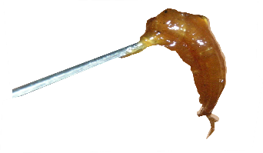
High doses of marijuana also are made in forms that look like honey (“hash oil”), wax (“budder,”) and hard amber (“shatter”).

More effects of using marijuana:
THC can make the brain release greater levels of a substance called dopamine. This can create a relaxed feeling and the “high” that many marijuana users seek. People use marijuana for a lot of different reasons: to feel good, to feel better, to feel different, or to fit in.
Not all people feel good from using marijuana. Some feel worried, afraid, freaked out, or not trusting of people around them. People who have taken lots of marijuana may see things that are not there (hallucinations), believe things that don’t make sense (delusions), and lose a sense of who they are.
Learning and memory. Marijuana use impacts the learning part of the brain. It can be harder to study, learn new things, or remember things that just happened. A study found that those who used marijuana a lot in their teens had a lower IQ when they became adults - even if they quit as adults.
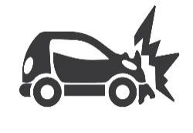
Coordination. THC affects the area of our brain that controls balance and movement. These effects can influence how people perform in sports and video games.
Driving. It’s not safe to drive while under the effects of marijuana. Marijuana affects a number of skills needed for safe driving: being alert, paying attention and coordination. Marijuana makes it hard to know how far away things are. You are less likely to react to signals and sounds on the road when using marijuana. Studies show the risk of being in a car crash is twice as much when a driver uses marijuana.
Making choices. THC affects the part of the brain that makes choices. Using marijuana can cause you to do things you might not do when you are not using marijuana. Things like unsafe sex, which can lead to sexually transmitted diseases (STDs) like HIV. Or getting in a car with someone who’s been drinking or is high on marijuana.
Some people think marijuana helps when they feel depressed, but studies show that smoking marijuana may make depression worse. Marijuana users have been shown to have higher levels of depression and more signs of depression. Heavy marijuana use as a teen may raise the risk of depression later in life, especially with girls.
Studies also show that using marijuana raises the risk of getting a mental illness called schizophrenia in people who are already at risk of getting it.

How can marijuana use affect school and social life?
Students who smoke marijuana tend to get lower grades and are more likely to drop out of high school. The effects of marijuana on attention, memory, and learning can last for days or weeks. These effects have a negative impact on learning and motivation. People who use marijuana often for a long time are less happy with their lives and have more problems with friends and family.
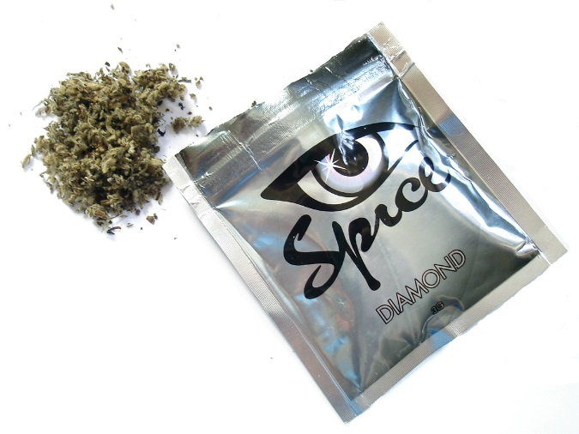
What is “spice”?
“Spice”, or synthetic marijuana (sometimes called “K2”) is smoked, vaped, or eaten like natural marijuana. Its effects can be stronger than natural marijuana due to its chemicals. Sometimes spice is called “natural,” “safe,” or a legal version of marijuana.
But spice is full of chemicals that are dangerous. Thousands of teens and young adults go to emergency rooms every year after using spice because they are throwing up, have a racing heart or high blood pressure, or have seizures and hallucinations.

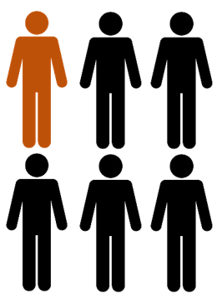
Is marijuana addictive?
Yes: marijuana can be addictive. A user may feel the urge to use marijuana again and again to feel the “high.” Using often enough can make a person have a hard time stop using even if they wanted to.
About 1 in 6 people who start using as a teen become addicted to marijuana. The chances of becoming addicted are higher when someone uses marijuana every day.
What causes one person to become addicted to marijuana and another not to depends on many factors. These factors include family history (genetics), the age someone starts using, using other drugs at the same time, relationships with family and friends, and being involved in school or positive activities.
People who are addicted to marijuana may feel bad when they stop using the drug. These are called withdrawal symptoms, and may include:
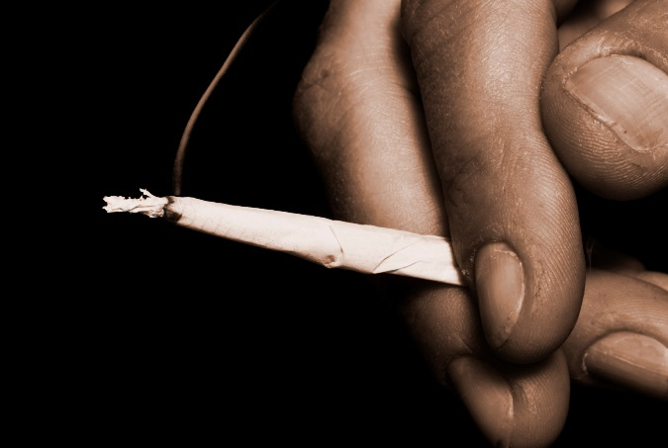
- Irritability
- Not sleeping
- Not wanting to eat
- Feeling anxious
- Craving marijuana
These effects can last for several days to a few weeks after drug use is stopped. Relapse (using the drug after you’ve quit) is common during this period because people also crave the drug to relieve these symptoms.

This document is available for download at www.sbirtoregon.org. Information compiled from the National Institute on Drug Abuse; National Institutes of Health; U.S. Department of Health and Human Services. All images licensed for use.

