Adolescent Prescription Drug Abuse

What is prescription drug abuse?
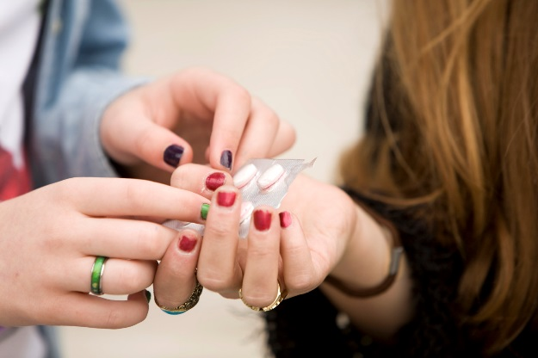
Prescription drugs are often strong medications, which is why they require a prescription from a doctor. When they are abused, they can be just as dangerous as illegal drugs. Prescription drugs can be abused in different ways:
Taking someone else’s prescribed medication. Even when someone takes another person’s medication for its intended purposes (such as to help with pain, to stay awake, or to fall asleep) it is drug abuse.
Taking a prescribed medication in a way other than prescribed. Taking your own prescription in a way that it is not meant to be taken is also abuse. This includes taking more of the medication than prescribed or changing its form. For example: breaking or crushing a pill or capsule and then snorting the powder.
Taking a medication to get high. Some types of prescription drugs also can produce pleasurable effects or “highs.” Taking the medication only for the purpose of getting high is considered prescription drug abuse.
Three kinds of prescription drugs that are most often abused:
Opioids are prescribed to help patients with pain. These include Vicodin, OxyContin, or codeine. Sometimes these drugs are called Hillbilly heroin, oxy, OC, oxycotton, percs, happy pills, or vikes.
Depressants are prescribed to help patients with anxiety or help a patient sleep, such as Valium or Xanax. Sometimes these drugs are called barbs, reds, red birds, phennies, tooies, yellows, yellow jackets; candy, downers, sleeping pills, tranks; Aminus, or zombie pills.
Stimulants are prescribed to help patients with attention deficit hyperactivity disorder (ADHD), such as Adderall and Ritalin. Sometimes these drugs are called Skippy, the smart drug, Vitamin R, bennies, black beauties, roses, hearts, speed, and uppers.

Aren’t prescription drugs safe?
Doctors consider a number of factors before prescribing drugs. People who abuse drugs might not know how these factors interact and put themselves at risk. Doctors take into account a person's weight, how long they've been prescribed the medication, and what other medications they are taking. Someone abusing prescription drugs may overload their system or put themselves at risk for dangerous drug interactions that can cause seizures, coma, or even death.

What are the health risks of abusing prescription drugs?
Abusing prescription drugs can cause dangerous short and long term health problems.

Abusing opioids can cause you to feel sleepy, sick to your stomach, and constipated. At higher doses, opioids can make it hard to breathe properly and can cause overdose and death.

Abusing stimulants can make you feel paranoid (feeling like someone is going to harm you even though they aren’t). It also can cause your body temperature to get dangerously high and make your heart beat too fast. This is especially likely if stimulants are taken in large doses or in ways other than swallowing a pill.

Abusing depressants can cause slurred speech, shallow breathing, sleepiness, disorientation, and lack of coordination. People who abuse depressants regularly and then stop suddenly may experience seizures. At higher doses depressants can also cause overdose and death, especially when combined with alcohol.

Can You Get Addicted to Prescription Drugs?
Yes. Prescription drugs that effect the brain, including opioids, stimulants, and depressants, may cause physical dependence that can turn into addiction. Dependence happens because the brain and body adapt to having drugs in the system for a while. A person may need larger doses of the drug to get the same initial effects. This is known as “tolerance.”

Medications that affect the brain can change the way it works—especially when they are taken over a long time or with bigger and bigger doses. They can change the brain, making it harder for a person to feel good without the drug and make it hard to stop using. This is no different from what can happen when someone takes illicit drugs. When a person is addicted to a drug, finding and using that drug can begin to feel like the most important thing —more important than family, friends, school, sports, or health.

When drug use is stopped, withdrawal symptoms can occur. It is one of the many reasons why a person should only take (and stop taking) prescription drugs under a doctor's care. Carefully following the doctor’s instructions for taking a medication can make it less likely that someone will develop dependence or addiction.

This document is available at www.sbirtoregon.org. Information used with permission from the National Institute on Drug Abuse; National Institutes of Health; U.S. Department of Health and Human Services. Images licensed for use.

