Adult illegal drug use

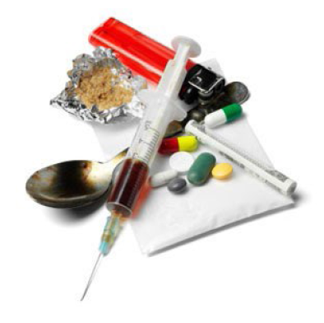
At first, people may decide for themselves whether to use illegal drugs. They may see what they like about drug use, and think that they can control their drug use.
However, drug use can take over someone’s life over time. A person may have less power to decide for themselves whether or not to use drugs. Studies show the parts of our brains that make choices are affected by heavy drug use. How we learn and remember things can change from using drugs. These changes may be why addiction to drugs is so hard to beat.
Drug use can make things that used to be fun less fun. A user may need to use drugs just to feel normal. People with heavy drug use can reach a point where they seek and take drugs,
even if it causes problems for themselves and loved ones.
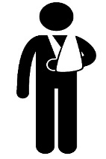
Some risks of occasional or short term drug use
- Aggression and violence
- Unsafe sex, forced sex
- Sleep problems
• Throwing up, fever, confusion
• Overdose, blackout
• Hurting yourself by accident

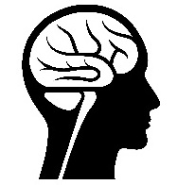
Some risks of heavy or long term drug use
- Trouble with the law
- Problems with family, friends, or at work
- Tolerance (needing larger doses to get the same effect)
- Withdrawal symptoms from quitting
- Mental health problems
- Anxiety, depression, mood swings
- Money problems

Some risks of injecting drug
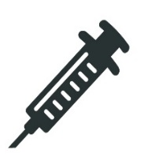
- Addiction
- Overdose
- Vein collapse
- Infection

- Sores and ulcers
- HIV
- Hepatitis

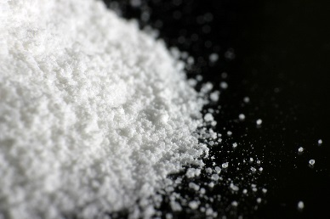
Cocaine (coke)
Cocaine is a drug made from the leaves of the coca plant from South America. It can be very addictive. For a short time, cocaine can make people feel good, have energy, and talk a lot. It can also make the heart beat faster and raise blood pressure. Some problems that can happen from using cocaine:
Long term:
- Intense craving, stress from the lifestyle
- Accidents, injury and financial problems
- Aggressive and violent behavior
- Sudden death from heart problems
- Tolerance and dependence

Short term:
- Hard time sleeping, racing heart, headaches and weight loss
- Feeling numb, tingling, clammy skin and skin scratching or picking
- Mood swings – anxiety, depression and paranoia

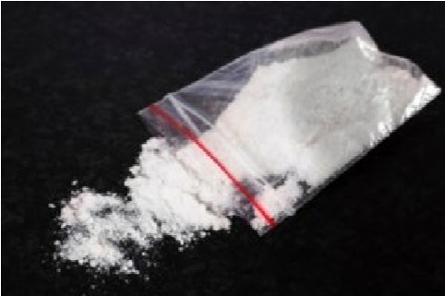
Meth (crystal meth)
Methamphetamine (meth) is a very addictive drug that looks like a white, odorless, bitter-tasting powder. Smoking or injecting meth works quickly, but because the pleasure also fades quickly, users often take repeated doses, in a “binge and crash” pattern. Some problems that can happen from using meth:
Short term:
- Hard time sleeping, weight loss,
- Jaw clenching, headaches and muscle pain
• Mood swings – anxiety, depression, agitation, mania and panic
- Shaking, irregular heartbeat and shortness of breath
Long term:
- Drowsiness, constipation
- Paranoia, aggressive and violent behavior
- Itching, nausea and vomiting
- Liver damage and brain bleeding
- Sudden death from heart problems
- Tolerance and dependence

Heroin (smack, junk)
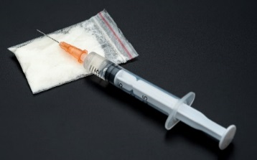
Heroin is made from poppy plant seeds. It can be a white or brown powder, or it can be a black, sticky goo. Heroin usually is injected with a needle, but it can be smoked or snorted. All three methods deliver the drug to the brain fast, which makes heroin risky for health problems and risky for addiction. Some problems that can happen from using heroin:
Short term:
- Fatal overdose
- Hepatitis and HIV
- Slowed (or even stopped) breathing
- Feeling sick to the stomach and throwing up
Long term:
- Collapsed veins
- Infection of the heart lining and valves
- Constipation and stomach cramping
- Liver or kidney disease
- Tolerance and dependence

Hallucinogens (LSD, mushrooms, PCP)
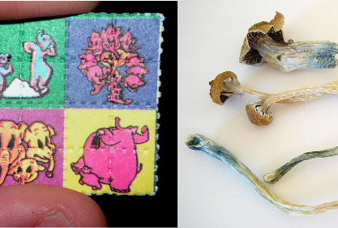
Hallucinogens are drugs made from certain plants and mushrooms. Hallucinogens cause people to see things, hear sounds and feel things that seem real but do not exist. These drugs produce quick, intense mood swings and the effects can vary greatly from person to person and from the amount taken. Some problems that can happen from using hallucinogens:
Short term:
- Nausea and throwing up
- Anxiety, panic, and paranoia
- Feeling numb, weak muscles, twitching or shaking
- Increased heart rate and blood pressure
Long term:
- Flash-backs
- Greater chance of mental illness (schizophrenia.)
- Tolerance, leading to higher doses
- Trouble with memory

MDMA (molly, ecstasy)
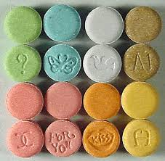
MDMA is a man-made drug that produces feelings of increased energy and emotional warmth toward others. It also changes how someone sees and feel things, and how they sense time. The drug’s effects last about 3 to 6 hours, but it is common for users to take a second dose of the drug when the effects of the first dose begin to fade. Many MDMA users take other drugs at the same time. Some problems that can happen from using MDMA:
Long term:
- Long-lasting confusion, depression
- Problems with attention, memory, and sleep
- Anxiety, impulsiveness, aggression
- Loss of appetite, less interest in sex
Short term:
- Tense muscles, teeth clenching
- Increased heart rate and blood pressure
- Confusion, depression, sleep problems
- High doses: liver, kidney, or heart failure

Substance use disorders

Substance use disorders are medical conditions that health professionals can diagnose when a patient’s drug use causes distress or harm. Below is a list of signs that can point to a substance use disorder. See if any of these signs apply to you.
In the past year, have you:
❑ Had times when you used drugs more, or longer, than you intended? More than once wanted to cut down or stop using drugs, or tried to, but couldn’t?
❑ More than once been in situations while or after using drugs that increased your chances of getting hurt (such as driving, using machines, walking in a dangerous area, or having unsafe sex)?
❑ Had to use drugs much more than you once did to get the effect you want? Or found that your usual use of drugs had much less effect than before?
❑ Still used drugs even though it was making you feel depressed or anxious or adding to another health problem? Spent a lot of time using drugs?
❑ Still used drugs even though it was causing trouble with your family or friends?
❑ Found that using drugs often made it harder to take care of your home or family? Or caused job troubles? Or school problems?
❑ Given up or cut back on activities that were important or interesting to you, or gave you pleasure, in order to use drugs?
❑ More than once gotten arrested, been held at a police station, or had other legal problems because of using drugs?
❑ Found that when the effects of drugs wore off you had trouble sleeping? Or had shaky hands, arms or legs? Started to sweat? Or felt things that were not there?

If things on this list apply to you, then drug use may be a cause for concern. The more items you checked on the list, the greater the need for change. A health professional can look at this list with you to see if a substance use disorder is present and help you decide what you want to do.

This document is available at www.sbirtoregon.org. Information compiled from sources including the National Institute on Drug Abuse; National Institutes of Health; U.S. Department of Health and Human Services. Images licensed for use.

